**NAN MUDHALVAN PROJECT**

**PROJECT REPORT OF**

**ETHEREUM DECENTRALIZED IDENTITY**

**SMART CONTRACT**

**TEAM NM ID - NM2023TMID06814**

K.RAJASHREE - B24FFB9E94D20219EE6448B8AFF8BE04

R.S.RHYTHEGA SRI - 3FE1629565913C59A8B4DE96C6998EE4

J.JANSHI - 8A97F70F078DD01967A41D4C875355B6

J.SABITHA - 06E061F2A6F24218B6E44AF0649DEE3C

**INDEX**

1. **INTRODUCTION**

Project Overview

Purpose

1. **LITERATURE SURVEY**

Existing problem

References

Problem Statement Definition

1. **IDEATION & PROPOSED SOLUTION**
2. Empathy Map Canvas

Ideation & Brainstorming

1. **REQUIREMENT ANALYSIS**

Functional requirement

Non-Functional requirements

1. **PROJECT DESIGN**

Data Flow Diagrams & User Stories

Solution Architecture

1. **PROJECT PLANNING & SCHEDULING**

Technical Architecture

Sprint Planning & Estimation

Sprint Delivery Schedule

1. **CODING & SOLUTIONING (Explain the features added in the project along with code)**

Feature 1

Feature 2

1. **PERFORMANCE TESTING**

Performace Metrics

1. **RESULTS**

Output Screenshots

1. **ADVANTAGES & DISADVANTAGES**
2. **CONCLUSION**
3. **FUTURE SCOPE**
4. **APPENDIX**

Source Code

GitHub & Project Demo Link

# 1. INTRODUCTION

Ethereum, a prominent blockchain platform, has opened up

exciting possibilities for various applications beyond just cryptocurrencies. One of these groundbreaking applications is the implementation of decentralized identity systems through smart contracts. Decentralized identity, often referred to as self-sovereign identity, is a concept that empowers individuals to take control of their digital identities, reducing reliance on centralized authorities and enhancing security, privacy, and user autonomy.

Ethereum decentralized identity smart contracts are at the heart of this paradigm shift. These smart contracts are self-executing, code driven agreements that enable users to assert and manage their identities on the Ethereum blockchain. By leveraging Ethereum's decentralized and immutable ledger, individuals can securely store and control their personal information, authentication data, and access credentials.

The Ethereum blockchain's robust security features make it difficult for malicious actors to tamper with or steal personal identity information. Users have the ability to share only the specific information needed for a given interaction, reducing the risk of oversharing personal data.

## 1.2 PURPOSE

The purpose of Ethereum Decentralized Identity Smart Contracts is to provide a secure, user-centric, and privacy-preserving solution for managing digital identities in a decentralized manner. Ethereum decentralized identity smart contracts enable individuals to take full control of their digital identities. Users can create, update, and manage their identity information without relying on central authorities or intermediaries. This user-centric approach empowers individuals to make decisions about who has access to their identity data and under what circumstances.

By leveraging the security features of the Ethereum blockchain, such as cryptographic hashing and immutability, these smart contracts enhance the security of digital identities. Storing identity data on the blockchain makes it resistant to tampering and unauthorized access, reducing the risk of identity theft and fraud. Users can selectively disclose only the necessary information for specific interactions. Ethereum decentralized identity solutions allow for minimal disclosure, which means users can share only the relevant data, preserving their privacy and minimizing the risk of oversharing personal information.

Ethereum smart contracts eliminate the need for trust in third party identity providers or centralized institutions. Instead, users can trust the cryptographic integrity and transparency of the blockchain, reducing the risk of data breaches and identity-related vulnerabilities.

# 2. LITERATURE SURVEY

## 2.1 EXISTING PROBLEM

One of the existing problems associated with Ethereum decentralized identity smart contracts is the challenge of Usability and Adoption. While decentralized identity solutions offer significant advantages in terms of security, privacy, and user control, they also come with usability issues that can hinder widespread adoption. Here are some specific aspects of this problem:

Complexity: Smart contracts, private keys, and blockchain interactions can be complex for the average user. Managing one's own identity through a decentralized system may require a level of technical understanding that many individuals do not possess.

**User Onboarding**:New users often find it challenging to set up and interact with decentralized identity smart contracts. The process of creating and securing private keys, as well as understanding wallet interactions, can be intimidating.

**Recovery Mechanisms**: While users have more control over their identity, the responsibility for safeguarding private keys also rests with them. If a user loses their private key, recovery mechanisms are limited, and there's a risk of permanent data loss.

**User Education**: There's a need for comprehensive user education to ensure that individuals understand the implications of decentralized identity management. Many users are unfamiliar with the concepts of public and private keys, which are central to decentralized identity systems.

**Integration Challenges**: Interacting with existing online services, especially those that rely on traditional identity authentication methods, can be difficult with decentralized identity. Many services and applications have not yet integrated with decentralized identity standards, making it challenging for users to utilize their decentralized identities.

**Scalability and Speed**:While blockchain technology has improved significantly, it still faces challenges related to scalability and speed. User authentication and identity verification must occur quickly and efficiently, which can be difficult to achieve on public blockchains during peak usage times.

## 2.2 REFERENCES

**1.** W3C Decentralized Identifiers (DIDs):

### •Website: W3C DID Specification

•The World Wide Web Consortium (W3C) provides standards and specifications for Decentralized Identifiers (DIDs), which are fundamental to blockchain-based identity solutions.

**2.** Verifiable Credentials Data Model:

### •Website: W3C Verifiable Credentials Data Model

•The W3C's Verifiable Credentials Data Model standardizes the format for issuing and verifying credentials on the web. 3. Sovrin Foundation:

### •Website: Sovrin Foundation

•The Sovrin Foundation is a leading organization in the development of decentralized identity solutions, offering valuable insights and resources.

1. SelfKey:
   * Website: SelfKey
   * SelfKey is a blockchain-based self-sovereign identity solution that provides insights into the practical implementation of decentralized identity.
2. Ethereum Developer Documentation:

### •Website: Ethereum Developer Documentation

•The official Ethereum developer documentation provides in-depth information on smart contract development and interacting with the Ethereum blockchain.

## 2.3 PROBLEM STATEMENT DEFINITION

In the digital age, the management and verification of personal identities pose significant challenges related to security, privacy, user control, and trust. Traditional identity systems rely on centralized authorities, leading to issues like data breaches, identity theft, and lack of user autonomy. Ethereum and blockchain technology have paved the way for decentralized identity solutions, but several critical problems must be addressed to ensure the widespread adoption and effectiveness of Ethereum Decentralized Identity Smart Contracts.

**Key Problem Areas:**

1. User-Friendly Onboarding: The current onboarding process for Ethereum decentralized identity solutions can be complex, requiring users to manage private keys and cryptographic operations. Simplifying the user experience while maintaining security is a crucial challenge.
2. Privacy and Data Minimization: Ensuring that users have control over their identity data and can selectively disclose information for specific interactions is a complex problem. Striking a balance between data minimization and usability is essential.
3. Interoperability: Different Ethereum-based identity projects may use varying standards and smart contract implementations, making it challenging to achieve seamless interoperability between applications and services.
4. Revocation and Recovery: Implementing robust mechanisms for identity revocation and recovery without compromising security is an ongoing challenge. Users must be able to regain control of their identity in case of key loss or compromise.
5. Scalability and Performance: Ethereum's scalability limitations can impact the efficiency of identity-related transactions and may hinder the development of high-performance decentralized identity solutions.
6. Identity Attestation and Verification: Ensuring that the data stored in decentralized identity smart contracts is accurate and reliable is a significant problem. Solutions for identity attestation and verification require development.
7. User Education and Awareness: Many individuals are not aware of the benefits and implications of decentralized identity solutions. A problem lies in educating and raising awareness among potential users and organizations.
8. Security Considerations: Decentralized identity systems must address evolving security threats, including social engineering, phishing attacks, and vulnerabilities in smart contract code.

# 3. IDEATION AND PROPOSED SOLUTION

## EMPATHY MAP CANVAS

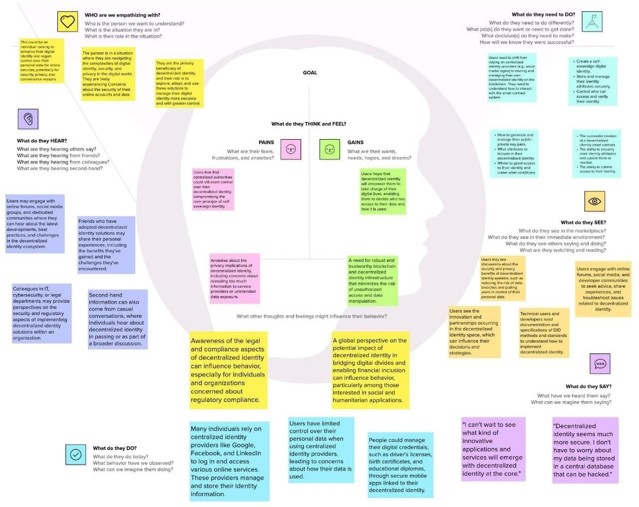

**3.2 IDEATION & BRAINSTORMING**

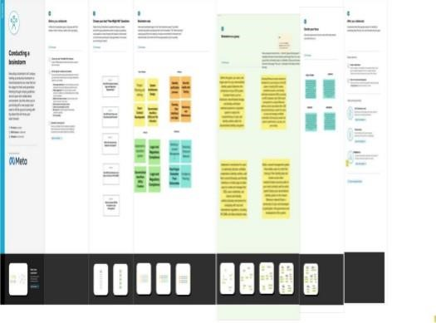

# 4. REQUIREMENT ANALYSIS

|  |  |
| --- | --- |
| REQUIREMENT | DESCRIPITION |
| User Registration | Users should be able to register their decentralized identity by providing personal information, such as name, email, and other relevant details |
| Identity Retrieval | Users should be able to retrieve their identity information by providing their Ethereum address or another identifier |

## FUNCTIONAL REQUIREMENT

**NON – FUNCTIONAL REQUIREMENT**

|  |  |
| --- | --- |
| Identity Update | Users should have the ability to update their identity information, reflecting changes in personal details |

|  |  |
| --- | --- |
| NON FUNCTIONAL REQUIREMENT | DESC RIPTION |
| Access Control | Implement role-based access control to ensure that only authorized users can make changes to their identity information. |
| Smart Contract Audits | Conduct security audits of the smart contract's code to identify vulnerabilities and risks. |
| Privacy | The smart contract should only collect and store the minimum necessary identity information to protect user privacy. |

# 5. PROJECT DESIGN

## DATA FLOW DIAGRAM

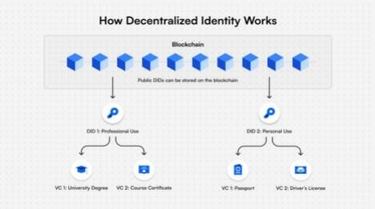

## SOLUTION ARCHITECTURE

For Ethereum decentralized identity smart contract project involves designing the overall structure of the system, its components, and how they interact.

**Components:**

**1. Ethereum Blockchain:**

* The Ethereum blockchain serves as the core platform for the decentralized identity smart contract. Identity data and transactions are stored and processed on the Ethereum network. **2. Smart Contracts:**
* The primary smart contract, often referred to as the "Identity Contract," manages user identities, user data, access control, and interactions with the Ethereum blockchain.
* Additional smart contracts may be used for features like key management and identity recovery.

1. **User Interfaces:**

•Frontend applications provide user-friendly interfaces for interacting with the smart contract. These interfaces allow users to register, update, and manage their identities.

1. **Blockchain Wallets:** 
   * Users require Ethereum wallets to access the decentralized identity system. Wallets store private keys and facilitate

transactions. Popular wallets like MetaMask can be integrated.

1. **Decentralized Identifiers (DIDs):** 
   * DIDs are fundamental to the identity system. They provide standard way to reference and verify identities on the

blockchain. The identity contract may generate and manage DIDs.

1. **Verifiable Credentials:** 
   * The system generates and stores verifiable credentials as data records, allowing users to share and prove their identity information when needed.
2. **Off-Chain Storage:** 
   * Sensitive identity data, such as personal information, may be stored off-chain in secure databases or distributed file systems, with references or proofs on-chain.

**Key Functionalities:**

1. **User Registration:**

•Users create their decentralized identity, which includes the generation of a DID and the storage of essential identity information on the blockchain.

1. **Identity Verification:**

•The system verifies the authenticity of user-provided identity information through cryptographic methods, enabling users to prove the validity of their data.

1. **Access Control:**

•Role-based access control mechanisms ensure that only authorized parties can update or access identity information.

1. **Data Privacy:**

•Sensitive information is stored securely and, when necessary, encrypted. Users have the ability to control who can access their data.

1. **Credential Issuance:** 
   * + Users receive verifiable credentials from trusted issuers, which can include educational institutions, governments, or organizations. **6. Credential Verification:**
     + The system allows users to present verifiable credentials when required, such as during job applications or online transactions.

**7. Event Logging:**

•All interactions and changes to identity information are logged as events on the blockchain for transparency and auditability.

**Security and Compliance:**

* 1. **Access Control and Permissions:**

•Implement access controls and permissions to ensure that only authorized users and entities can modify and access data.

* 1. **Data Encryption:**

•Encrypt sensitive data both on and off the blockchain to protect user privacy.

* 1. **Audit Trails:**

•Maintain detailed audit logs to track changes to identity data and monitor for unauthorized activities.

* 1. **Legal and Regulatory Compliance:**

•Ensure compliance with relevant data protection and privacy regulations, adapting the system to meet legal requirements as necessary.

1. **PROJECT PLANNING & SCHEDULE:**

1. Design and Architecture:
   * System Architecture: Plan the overall architecture of the

decentralized identity system, including smart contract structure, databases, and user interfaces.

* + Security Design: Design security measures, access control mechanisms, and data encryption strategies.
  + User Experience (UX) Design: Develop the user interface and user experience design if applicable.

1. Development:
   * Smart Contract Development: Code the Ethereum smart contract according to the design specifications.
   * Frontend Development: If there is a user interface, develop the frontend to interact with the smart contract.
   * Testing: Conduct comprehensive testing, including unit testing, integration testing, and security testing.
2. Deployment:
   * Deployment Plan: Plan the deployment of the smart contract to the Ethereum blockchain. Decide on the Ethereum network (mainnet or testnet) for deployment.
   * Monitoring and Alerts: Set up monitoring tools and alerts to track the performance of the smart contract after deployment.

## TECHNICAL ARCHITECTURE

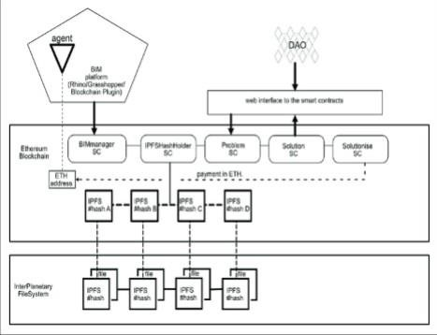

## SPRINT DELIVERY SCHEDULE

**Sprint 1: Project Setup and Planning (2 weeks)**

* Define project scope and goals.

•Create a project plan and set up the development environment. •

Gather initial requirements.

* Identify key stakeholders and establish communication channels.
* Define the overall architecture of the decentralized identity smart contract.

**Sprint 2: Smart Contract Development (3 weeks)**

* Set up the Ethereum development environment.
* Define the data structure and schema for decentralized identity. • Implement basic smart contract functionality for identity creation. • Begin unit testing and code reviews.
* Create a preliminary documentation outline.

**Sprint 3: Identity Management (3 weeks)**

* Implement identity management features (update, delete, recover, etc.).
* Integrate encryption and security measures.
* Continue unit testing and code reviews.
* Develop a user-friendly interface (e.g., web3.js for interactions). •

Update documentation and begin creating developer guides. **Sprint**

**4: Identity Verification (2 weeks)**

* Implement identity verification methods (e.g., attestations). • Enhance security measures for identity verification. • Test the verification process thoroughly.
* Continue updating documentation and developer guides.

**Sprint 5: Integration and Testing (3 weeks)**

* Integrate the decentralized identity smart contract into a test environment.
* Test interoperability with other systems and protocols.
* Perform extensive unit and integration testing.
* Document test cases and results.
* Update developer guides.

**Sprint 6: Deployment and User Testing (2 weeks)**

* Deploy the decentralized identity smart contract on the Ethereum mainnet or testnet.
* Conduct user testing and gather feedback.
* Address any issues or bugs discovered during user testing. • Refine the documentation and create end-user guides.

# 7. CODING AND SOLUTION

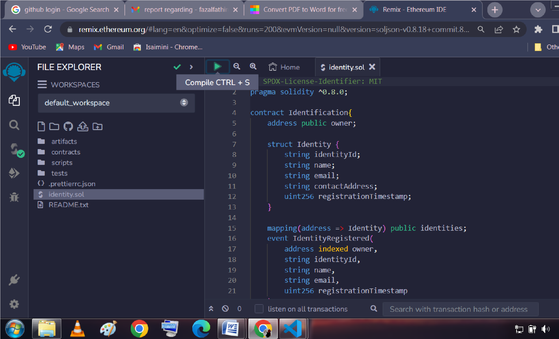**Feature 1:**

* **Identity Creation and Management:** 
  + This feature involves the ability for users to create and manage their decentralized identities on the Ethereum blockchain. Users should be able to register their identity by providing relevant information and possibly associating it with a unique identifier or key pair. Additionally, users should have the capability to update, recover, or delete their identity as needed.

The coding phase would focus on implementing the smart contract functions and logic to enable these identity management operations.

**Feature 2 :**

* **Identity Verification and Attestations:** 
  + Identity verification is a critical feature in a decentralized identity system. Users should be able to provide verifiable claims or attestations from trusted third parties to confirm aspects of their identity. During the coding phase, you would implement the mechanisms to allow users to request and receive attestations from entities, as well as to validate these attestations. This may involve the development of cryptographic verification methods and integration with external systems or oracles to verify the claims. Security measures and encryption techniques should also be implemented to protect the integrity of these attestations.

# 8. PERFORMANCE TESTING

## 8.1 PERFORMANCE METRICES

1. User Adoption Rate:

Measure the rate at which users are adopting and using the decentralized identity system. A high adoption rate is indicative of successful implementation.

1. User Satisfaction Score:

Collect user feedback and use surveys or feedback mechanisms to assess user satisfaction with the system. A high satisfaction score reflects a positive user experience.

1. Identity Verification Speed:

Measure the time it takes for the system to verify user identities. Faster verification can improve user experience.

1. Smart Contract Gas Efficiency:

Monitor and optimize the gas consumption of smart contracts to reduce transaction costs and ensure cost-effectiveness.

1. Transaction Throughput:

Track the number of transactions the system can process per unit of time to ensure it can handle concurrent users efficiently.

1. Security Audit Findings:

Keep track of security audit results and the number of identified vulnerabilities. Monitor the time it takes to remediate these issues.

1. Data Privacy Compliance:

Ensure that the system complies with data privacy regulations and measure the number of privacy-related incidents or breaches.

1. Cost Reduction:

Monitor the reduction in costs related to identity management by comparing expenses before and after implementing the decentralized identity system.

# 9. RESULTS

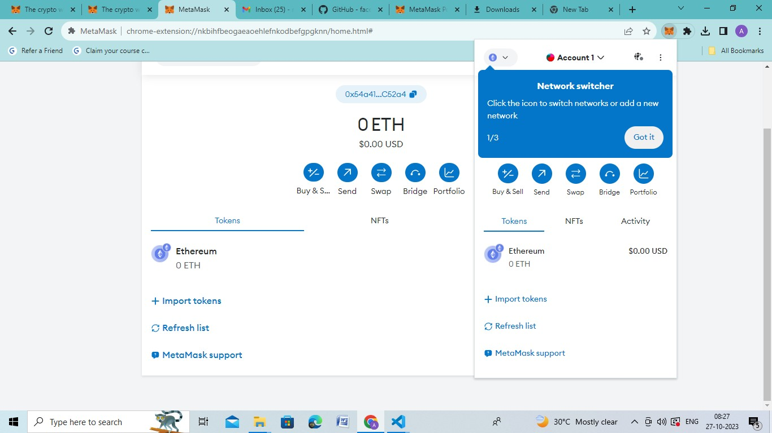

## 9.1 OUTPUT SCREENSHOTS

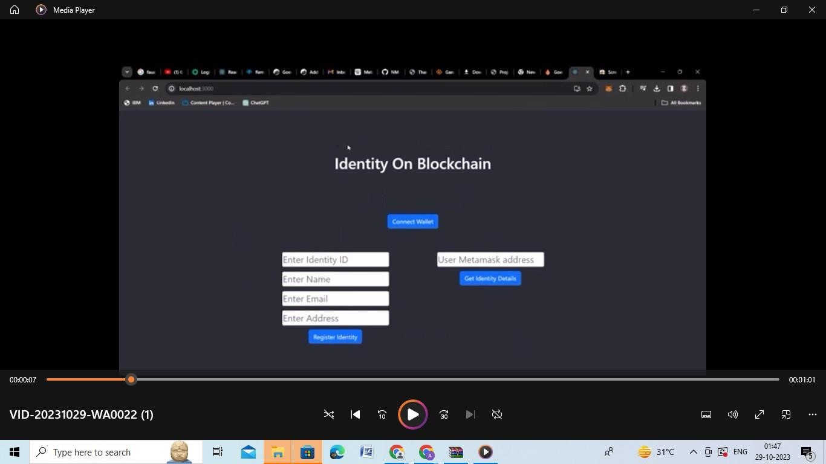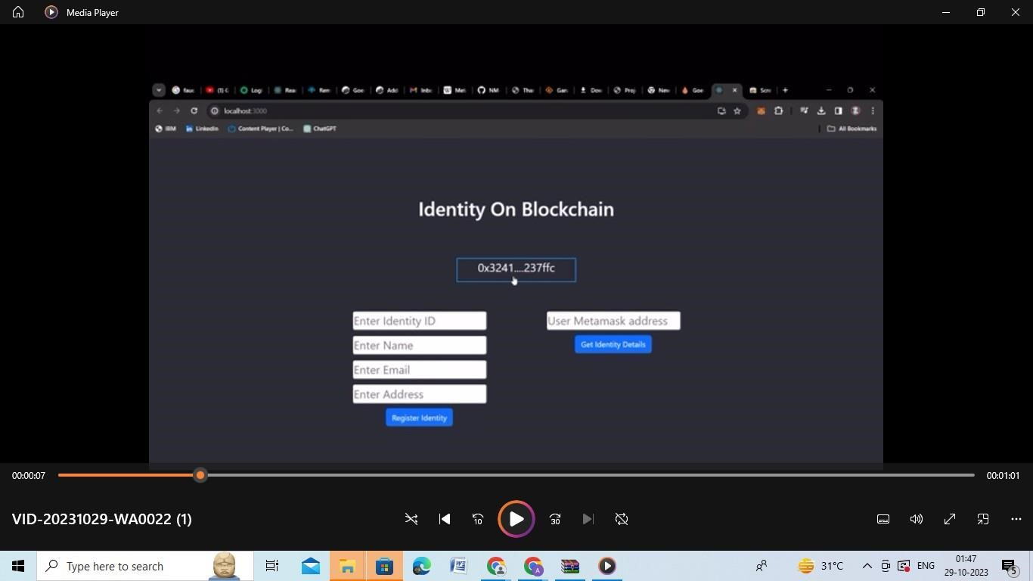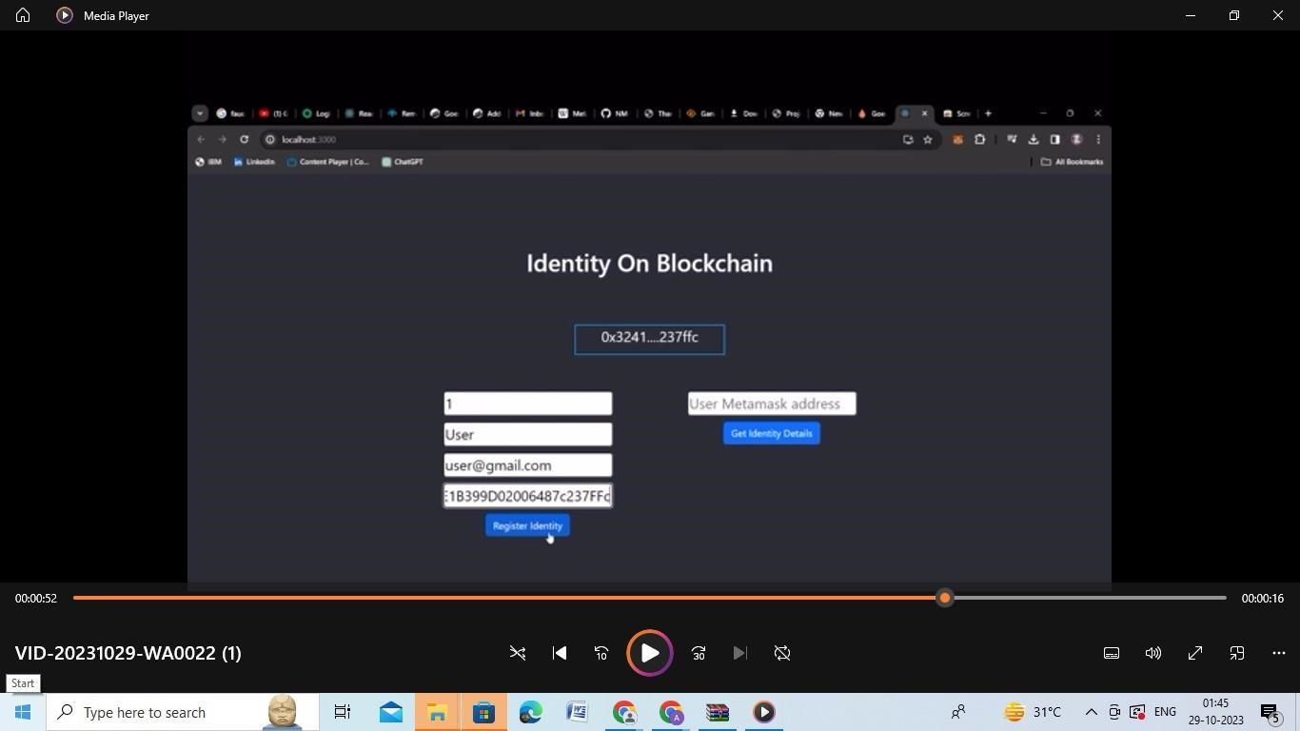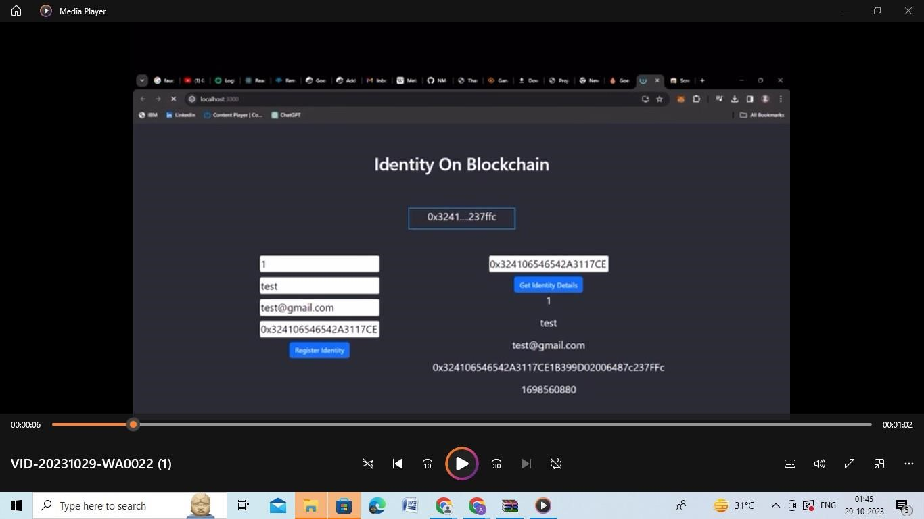

**10. ADVANTAGES & DISADVANTAGES Advantages:**

1. Secure and Trustworthy Identity Management:

Users can securely manage their identity information on blockchain.

* + The smart contract is resistant to unauthorized access and tampering, ensuring the integrity and confidentiality of user data.

1. Privacy-Respecting Solution:
   * Users have control over their data and can grant or revoke access to third parties as per their consent.
   * Sensitive identity information is stored and transmitted securely, preserving user privacy.
2. Interoperability and Standard Compliance:
   * The decentralized identity system complies with recognized standards like DID and Verifiable Credentials, allowing for interoperability with other identity systems and blockchain applications.
3. Scalability and Performance:
   * The system performs well, with optimized gas usage and responsiveness to accommodate a growing number of users.
   * Integration with Ethereum Layer 2 solutions enhances scalability and reduces transaction costs.
4. Regulatory Compliance:

•The system adheres to relevant legal and regulatory requirements related to data protection and privacy, reducing the risk of legal issues.

**Disadvantages:**

1. Complexity:
   * Implementing a decentralized identity system can be complex and may require significant development and maintenance efforts.
2. Usability Challenges:

•Managing identity through blockchain can be less intuitive for some users, potentially leading to usability issues.

1. Data Loss Risks:
   * If users lose access to their private keys or there are security breaches, there's a risk of permanent data loss.
2. Scalability Challenges:
   * As the user base grows, the blockchain may face scalability challenges, causing delays and increased transaction costs.
3. Smart Contract Vulnerabilities:

•Smart contracts are vulnerable to coding errors and security

flaws, potentially leading to exploits and data breaches.

# 11. CONCLUSION

In conclusion, the development and implementation of an Ethereum decentralized identity smart contract present a promising solution for enhancing security, privacy, and user control in identity management. By leveraging the blockchain's inherent trustworthiness and immutability, users gain the ability to securely manage their identity information and grant or revoke access as needed. This not only empowers individuals but also offers a robust defense against identity theft and fraud.

Ultimately, the success of an Ethereum decentralized identity smart contract project hinges on striking the right balance between these advantages and disadvantages. Through careful planning, continuous monitoring, user education, and responsiveness to evolving needs and standards, such a project has the potential to revolutionize identity management, providing users with greater control and security in an increasingly digital world.

**12. FUTURE SCOPE:**

* Global Identity Standards: The establishment of global standards for decentralized identity, including DID and Verifiable Credentials, will facilitate cross-platform and cross-border interoperability. These standards will be essential for a truly decentralized identity ecosystem.
* Enhanced Privacy Solutions: Ongoing development of privacy-preserving technologies, such as zero-knowledge proofs and advanced encryption, will bolster the privacy and security of decentralized identity systems.
* Blockchain and Layer 2 Evolution: The evolution of blockchain technology and Layer 2 scaling solutions will address scalability concerns, enabling decentralized identity systems to handle a growing number of users and transactions efficiently.
* User-Centric Control: The focus will continue to shift towards user-centric control and consent mechanisms, allowing individuals to have granular control over who accesses their data and for what purposes.

# 13. APPENDIX

## GITHUB LINK

[https://github.com/fazal-lab/Ethereum-Decentralised-IdentitySmart-Contract.git](https://github.com/fazal-lab/Ethereum-Decentralised-Identity-Smart-Contract.git)

## PROJECT DEMO LINK

<https://youtu.be/3t0e5_JNYaU>